3.3 Instructions for running XT-Package-Manager

3.3.1. Updating XT-Package-Config.json to ipfs

Prerequisite

- IPFS
- Node js(16)
- xt-package-manager downloaded from Github

A Updating XT-Package-Config.json file to IPFS

Note: Need to wrap the file inside the directory when uploading to IPFS we can use -w in ipfs add to wrap files inside directory

- Open terminal at the root of verification directory and run command

Ipfs add ./XT-Package-Config.json -w

-w is used to wrap in a directory

Note the Cid code which will be used to update in xt-package-manager

3.3.2 Instruction for running XT-Package-Manager

A To install required dependencies

- Go to xt-package-manager directory open terminal at the root directory
- Run command npm install

B To run xt-package-manager

C Configuring file for xt-package-manager

- Open setting.json file inside the xt-package-manager directory

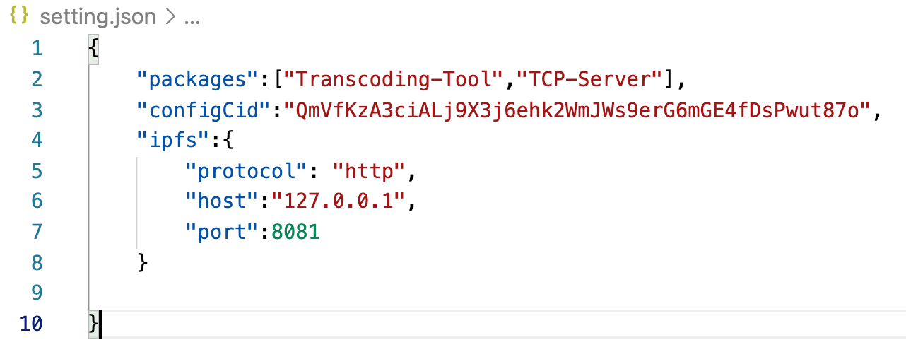

Packages: package which needs to be downloaded “Transcoding-Tool” and “TCP-Server”
configCid: Cid code for XT-Package-Config.json which we generated in Step 4.1
ipfs : port at which ipfs gateway is running

D To run xt-package-manager

- Go to xt-package-manager directory open terminal at the root directory
- Run command npm start
This will first download the config file from ipfs and verify the signature for the content in the packages. If it succeeds, it will check the he destination folder for the package and compare the cid of the local file with the ipfs file. If there is a difference, the download will start for particular package. Once the download is complete, it remove the existing container and deploys to a new container and runs the container mounting a volume at /home/node/media.

